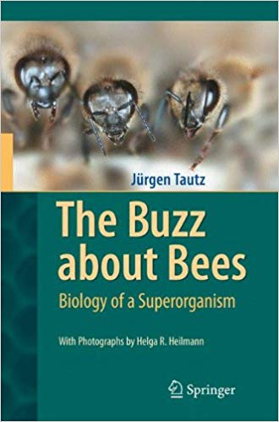

The Buzz about Bees

By Jurgen Tautz

Tis book, already translated into ten languages, may at frst sight appear to be just about honeybees and their biology. It c- tains, however, a number of deeper messages related to some of the most basic and important principles of modern biology. Te bees are merely the actors that take us into the realm of phys- ology, genetics, reproduction, biophysics and learning, and that introduce us to the principles of natural selection underlying the evolution of simple to complex life forms. Te book destroys the cute notion of bees as anthropomorphic icons of busy self-sacr -i fcing individuals and presents us with the reality of the colony as an integrated and independent being?a “superorganism”?with its own, almost eerie, emergent group intelligence. We are s- prised to learn that no single bee, from queen through drone to sterile worker, has the oversight or control over the colony. - stead, through a network of integrated control systems and fee- backs, and communication between individuals, the colony - rives at consensus decisions from the bottom up through a type of “swarm intelligence”. Indeed, there are remarkable parallels between the functional organization of a swarming honeybee colony and vertebrate brains.